**Mild to Moderate evaluation**

Sample_ID: **TYYAKR (CAT)**

Link: [https://release.animalbiome.com/pet/assessment/report/summary/68391cce-7e0d-4545-a7a0-41300efc867b](TYYAKR_2021-10-14_.docx)

Mild to Moderate

Cats and dogs:

Any Two

(High Yellow Flag Megamonas OR (failed)

High Yellow Flag Sutterella OR (failed)

High Yellow Flag Collinsella OR (**passed**)

Low Yellow Flag Bacteroides OR (failed)

Low Yellow Flag Blautia (failed)

)

OR

Cats: 8-10 Yellow Flags: 7 (failed)

OR 5-8 Red Flags: 4 (failed)

OR diet recommendation of increase fiber **(passed)**

OR diet recommendation of increase protein (failed)

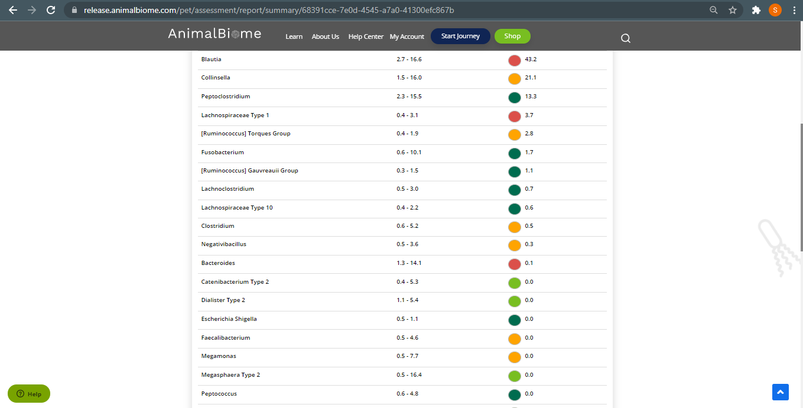



The result: **False False False True**

Expected result: Mild to Moderate

Achieved result: passed

